**Earthquakes & Volcanic Eruptions: Summary of Major Findings**

**Chloe, BJ, Aparna, Adote**

**Question 1: What countries had the most earthquakes/ volcanic eruptions from 1900- 2018?**

Our first question was regarding the countries that experienced the greatest number of significant earthquakes and/or the greatest number of significant volcanic eruptions. The country that experienced the greatest number of significant earthquakes was China, with a total of 347 between 1900 and 2018. Indonesia, Japan, Iran and the USA (in descending order) also experienced a high number of earthquakes as shown by the first graph below. The country that experienced the greatest number of significant volcanic eruptions was Indonesia, with 121 events. Japan, the Philippines, Italy and the USA (in descending order) also experienced a high number of volcanic eruptions as shown by the second graph below. It is interesting to note that Indonesia, Japan and the USA are included in the top counts for both earthquakes and eruptions.

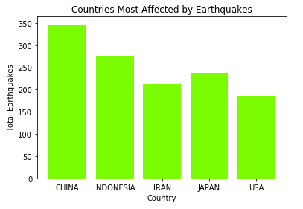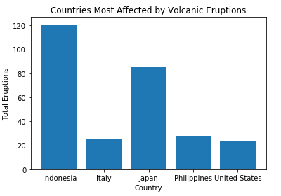

**Question 2: What decade had the most earthquakes/ volcanic eruptions?**

Our second question focused on what decade the greatest number significant of earthquakes and/or the greatest number of significant volcanic eruptions occured. From the graph below, it can be seen that the 2000s had the greatest number of significant earthquakes (597) and the 1990s had the greatest number of significant volcanic eruptions (70). Looking at the graph, it does not look as though trends in the number of earthquakes are related to trends in the number of eruptions that occured per decade. Overall though, it looks as though the number of events has increased in the more recent decades.

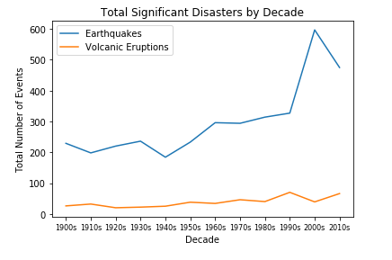

**Question 3: Which decade had the most deaths caused by these disasters?**

After looking at disasters by decade in our second question, we were interested in understanding which decade had the most deaths caused by those disasters. For earthquakes, the 1920’s and then 1970’s had the greatest number of deaths, both above 400,000 deaths. For volcanic eruptions, the 1900’s and the 1980’s had the most deaths with about 34,000 and 27,000 respectively. Looking at the scale of the graphs, it can be seen that by decade earthquakes are up to is 10x more deadly than volcanic eruptions. This is because earthquakes are unpredictable in timing and location of their occurrence.Also, a possible reason for the drastic decrease in deaths from volcanic eruptions from the 1900’s and the 1980’s to today may be to due improvements in technology, which allow for evacuations before an eruption occurs.

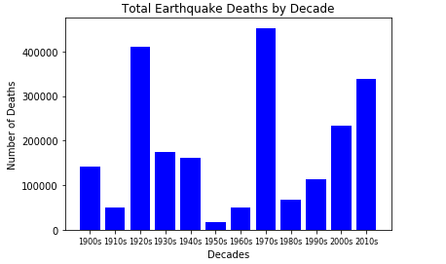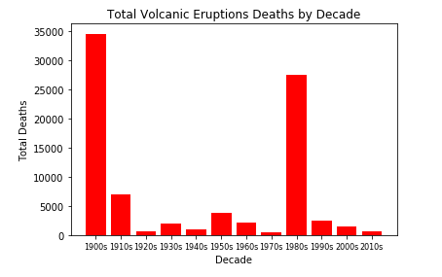

**Question 4: How are earthquake magnitude and damage ($) related?**

For our fourth question, we were interested in the relationship between earthquake magnitude and damage caused (in millions of dollars). We hypothesized that as magnitude increased, so would the amount of damage. The first scatter plot below is an overall representation of our data. The second scatter plot is a subset since most of our data was in the $0-$50,000 (millions) range. From these plots, we can see that there is possibly a trend of increasing damage as magnitude increases, although it is less pronounced that we would have originally assumed. We also have not had an opportunity to calculate the statistical significance of this relationship.

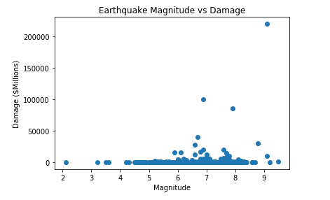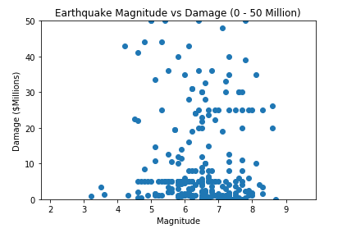

**Question 5: Where do earthquakes and volcanic eruptions happen around the world?**

To further our understanding of where these events occurred, we used gmaps to map the disasters around the world. As discussed before, these maps help to show the large number of significant earthquakes that occured between 1900 and 2018. A much smaller number of volcanic eruptions occurred during this time period. In addition, some of the locations of the earthquakes overlap with the eruption locations, but there are also many places, such as in the Middle East, that have no volcanic eruptions but large amounts of significant earthquakes.

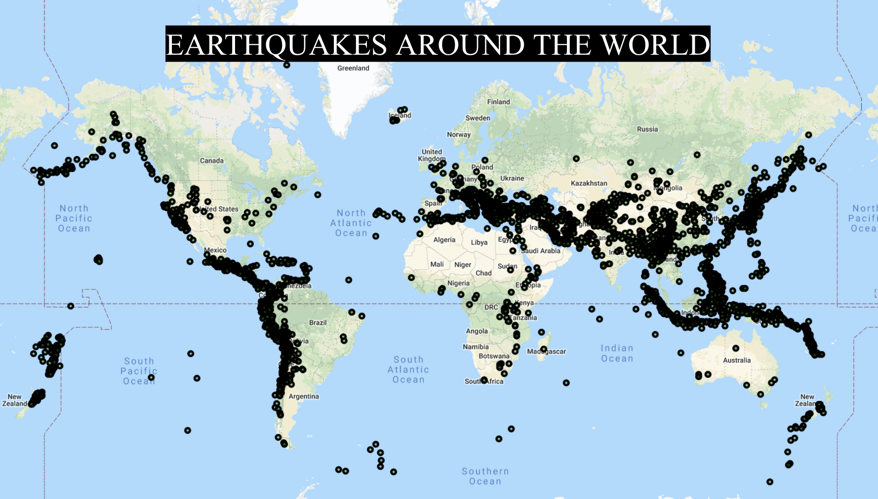

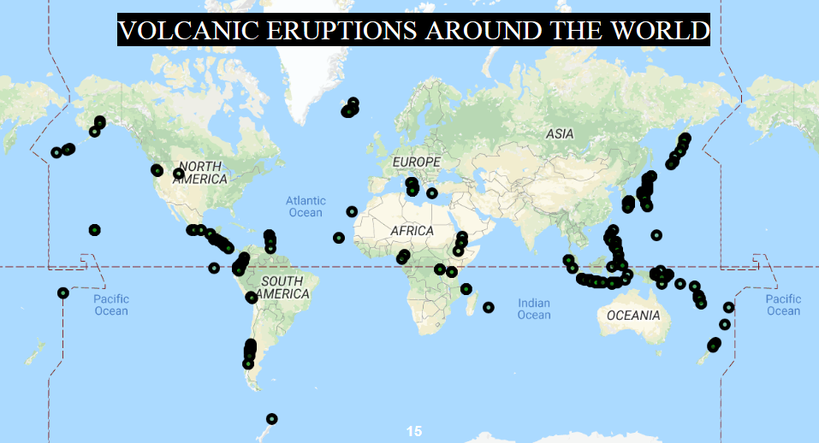

**Question 6: Which states had the most disasters in the US from 1900 to 2018?**

Finally, we wanted to understand where in the US most of these significant events occured. Since earthquakes occur more often than volcanic eruptions, we thought it would be more relevant to look at those statistics. Our results showed that California and Alaska had the greatest number of significant earthquakes, with both having more than 60 events between 1900 and 2018. This makes sense as California and Alaska are located on the boundary of the Pacific Plate, which is called the Ring of Fire. While these results are not surprising, it is interesting to see the other states, such as Nevada, Oklahoma and Washington, that have had more than one significant earthquake in the last 100 or so years.

